**Liquid Absorption Capacity Analysis**

*-Stat461 Final Project*

**Abstract:**

In this report, we want to determine the differences of liquid absorption capacity between different types of tissues and liquids. We choose three types of tissues and four types of liquids in the market.

We drip different types of liquids onto different types of tissues, and record the number of drops needed for the liquid passing through the first piece of tissue. We conclude that different types of tissue have different liquid absorption capacity with the same liquid. Different types of liquid do not affect the liquid absorption capacity for each tissue. However, different combinations of tissue types and liquid types can affect the liquid absorption capacity of tissue paper.

**Project Design:**

Nowadays, tissue is very commonly used in people’s daily life. The main job of tissue is to wipe things. However, there are different types and brands in the market for different uses.

We conduct an experiment to study liquid absorption capacity of different types of tissues with different types of liquid. Among all brands of tissue, we choose three types of tissues from the Great Value brand:  Ultra soft facial tissue, Lotion soft facial tissue, and Everyday soft facial tissue. We also choose four types of liquid: water, pepsi, milk, and soy sauce.

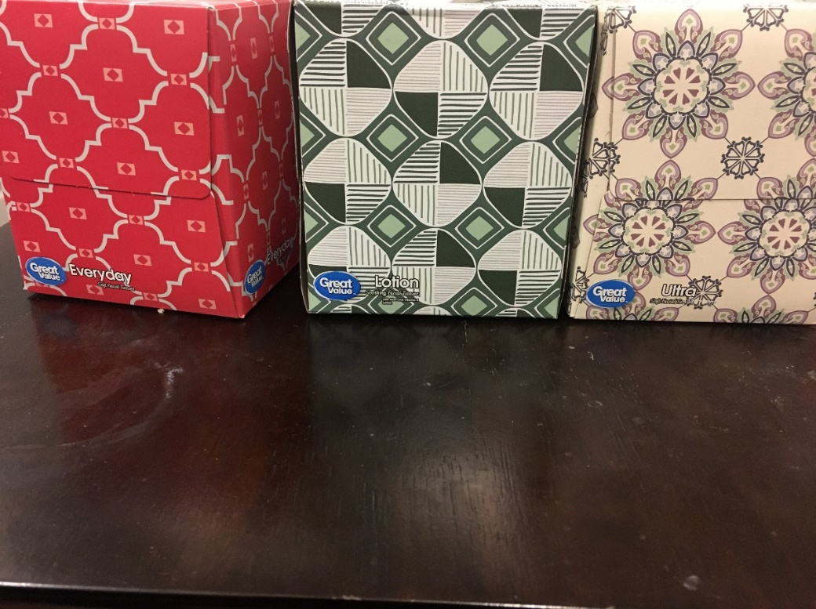

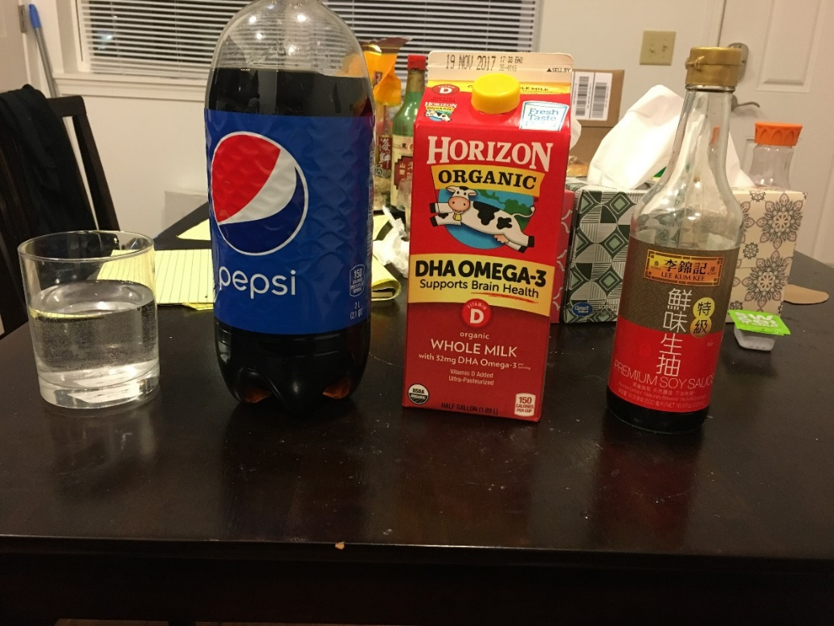

We take one piece of tissue, and hold it up into the air. Then, use a dropper to drip one type of liquids onto the same spot of the tissue. Keep dripping until the liquid passes through the tissue. Record the number of drops needed. Repeat this procedure 3 times with the same type of tissue and liquid. Then repeat this procedure for all possible combinations of tissues and liquids. In the end, we collected 36 data points of number of drops and 3 data points for each combination of tissues and liquid.

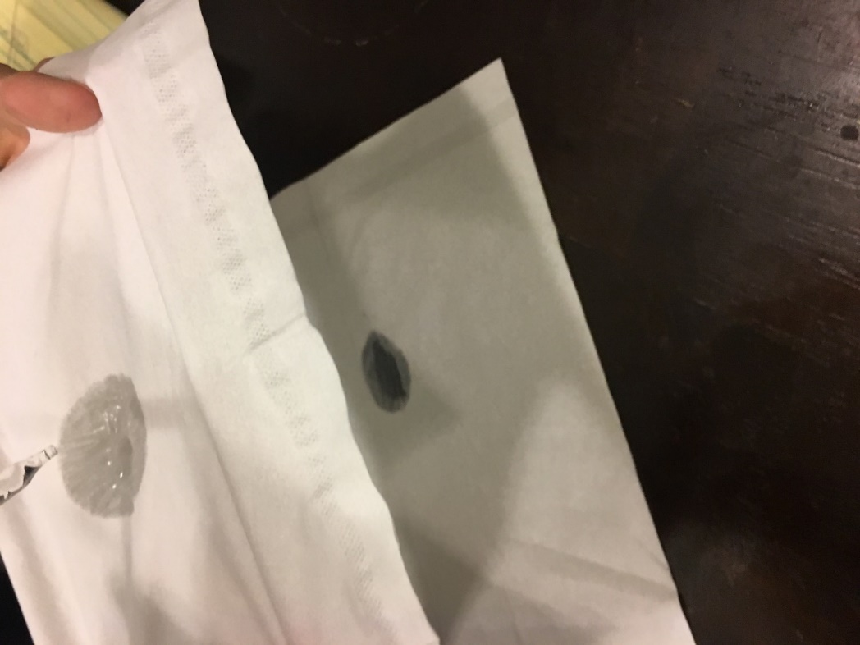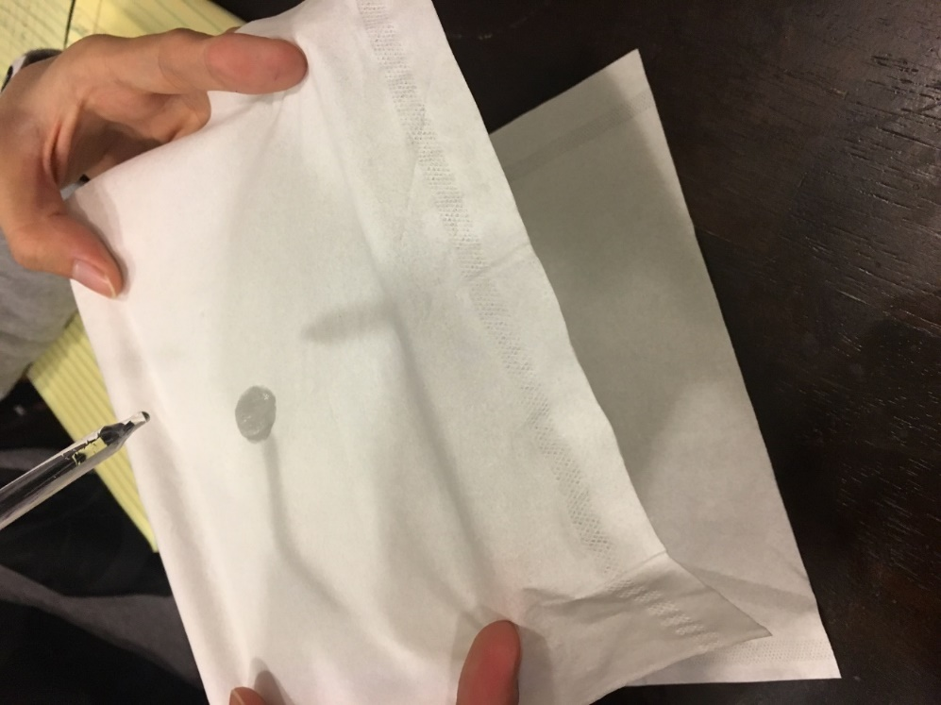

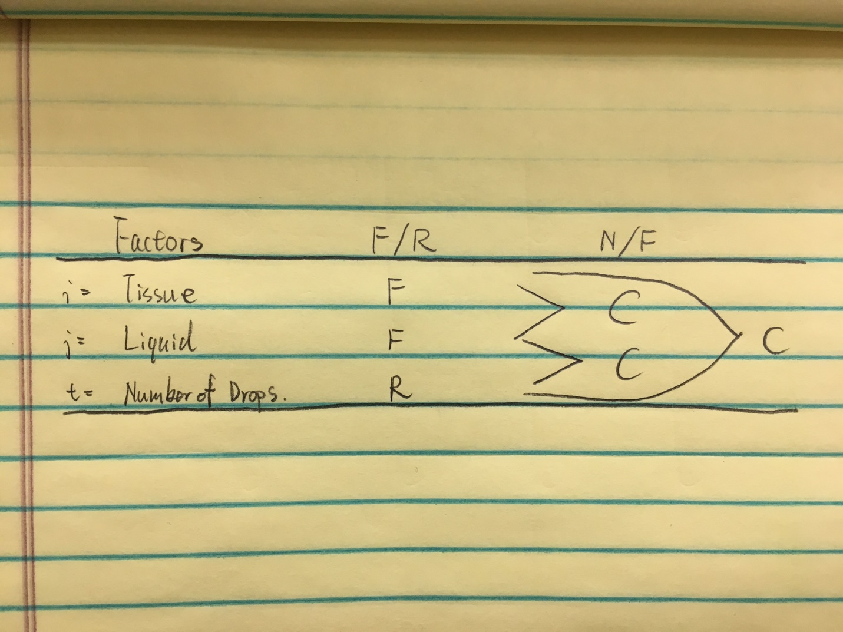

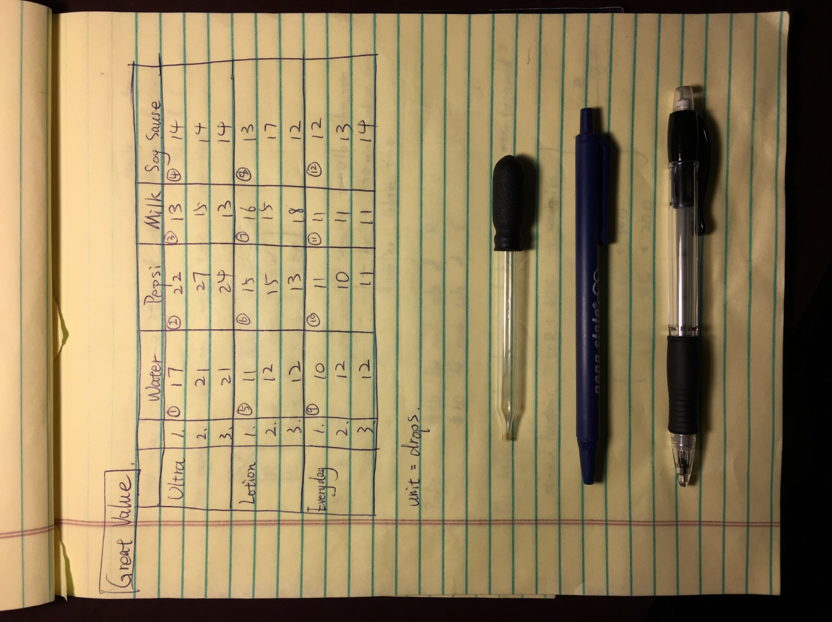

Now, we obtain two fixed factors “tissue” and “liquid”. We fit this data into a 2-way complete model with one interaction term between “tissue” and “liquid” since they crossed with each other. The response is the number of drops of liquid, which is set as “numdrops” in R.

This is not a completely random design because treatments are not randomly assigned to each experiment units.

**Data Analysis:**

First, we employ the 2-way complete model:

with iid.

= number of drops on tissue with liquid .

= ultra, lotion, everyday

= water, pepsi, milk, soy

= 1, 2, 3

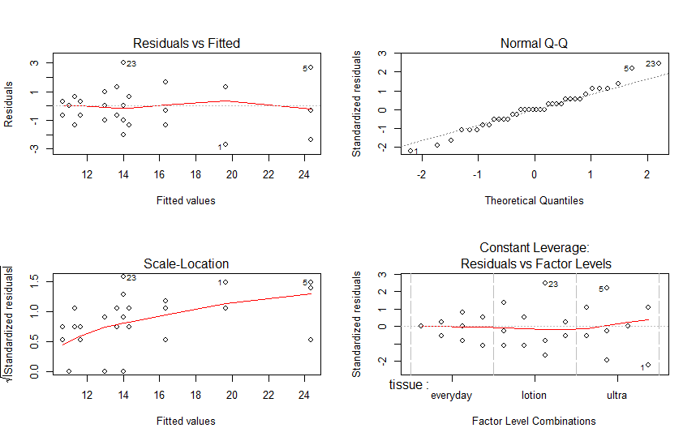

By observing the graph above, we can see that the residual plot does not satisfy the assumption of constant variance. Thus, we decide to use transformation: inverse of response.

Then, we have the following model:

with iid.

= inverse of the number of drops on tissue with liquid .

= ultra, lotion, everyday

= water, pepsi, milk, soy

= 1, 2, 3

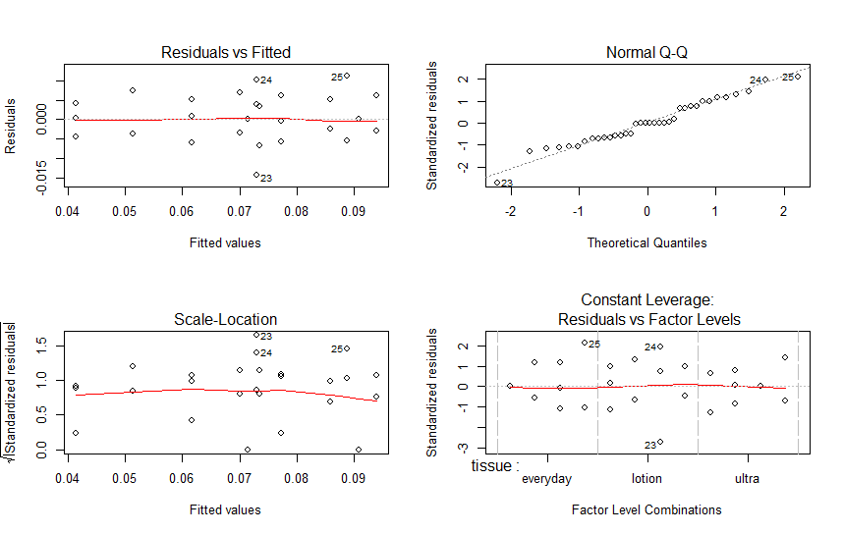

Now, the residual plot satisfies the assumption of constant variance and the Q-Q plot satisfies the assumption of normality. We can do further study.

|  |
| --- |
| > anova(model2)  Analysis of Variance Table  Response: 1/(numdrops)  Df Sum Sq Mean Sq F value Pr(>F)  tissue 2 0.0048204 0.00241018 58.1235 6.307e-10 ***  liquid 3 0.0002886 0.00009619 2.3198 0.1008  tissue:liquid 6 0.0033024 0.00055041 13.2735 1.338e-06 ***  Residuals 24 0.0009952 0.00004147  ---  Signif. codes: 0 ‘***’ 0.001 ‘**’ 0.01 ‘*’ 0.05 ‘.’ 0.1 ‘ ’ 1 |

**For interaction term**:

Test-statistic = = 13.2735

We reject null hypothesis since p-value is 1.338 × 10-6, which is smaller than 0.05. So we conclude that the interaction of tissue and liquid has significant effects on the number of drops.

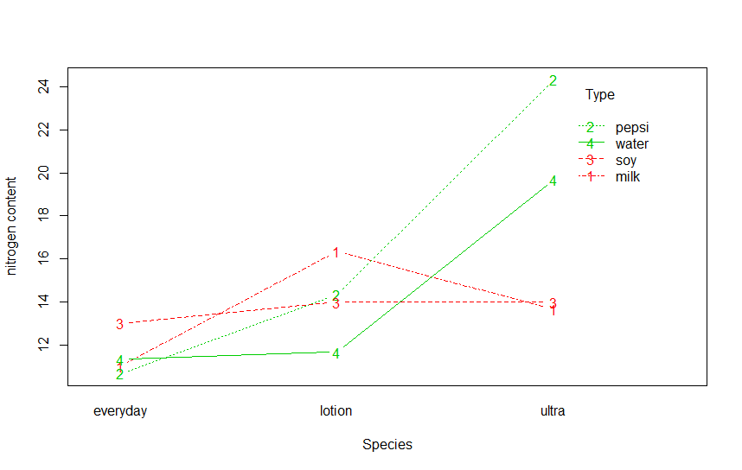

According to the plot, there are huge interaction effects between two variables.

|  |
| --- |
| > lm_interaction=lsmeans(model2,~tissue:liquid)  > cld(lm_interaction,alpha=0.05)  tissue liquid lsmean SE df lower.CL upper.CL .group  ultra pepsi 0.04138608 0.003717815 24 0.03371289 0.04905928 1  ultra water 0.05135387 0.003717815 24 0.04368068 0.05902707 12  lotion milk 0.06157407 0.003717815 24 0.05390088 0.06924727 23  lotion pepsi 0.07008547 0.003717815 24 0.06241228 0.07775866 234  ultra soy 0.07142857 0.003717815 24 0.06375538 0.07910177 34  lotion soy 0.07302665 0.003717815 24 0.06535345 0.08069984 345  ultra milk 0.07350427 0.003717815 24 0.06583108 0.08117747 345  everyday soy 0.07722833 0.003717815 24 0.06955513 0.08490152 3456  lotion water 0.08585859 0.003717815 24 0.07818539 0.09353178 456  everyday water 0.08888889 0.003717815 24 0.08121570 0.09656208 456  everyday milk 0.09090909 0.003717815 24 0.08323590 0.09858228 56  everyday pepsi 0.09393939 0.003717815 24 0.08626620 0.10161259 6  Results are given on the ( (not the response) scale.  Confidence level used: 0.95  P value adjustment: tukey method for comparing a family of 12 estimates  significance level used: alpha = 0.05 |

By observing the chart above, we can conclude that:

* Ultra tissue with Pepsi has less inverse of number of drops than lotion tissue with milk has.
* Ultra tissue with Pepsi has less inverse of number of drops than lotion tissue with Pepsi has.
* Ultra tissue with Pepsi has less inverse of number of drops than ultra tissue with soy sauce has.
* Ultra tissue with Pepsi has less inverse of number of drops than lotion tissue with soy sauce has.
* Ultra tissue with Pepsi has less inverse of number of drops than ultra tissue with milk has.
* Ultra tissue with Pepsi has less inverse of number of drops than everyday tissue with soy sauce has.
* Ultra tissue with Pepsi has less inverse of number of drops than lotion tissue with water has.
* Ultra tissue with Pepsi has less inverse of number of drops than everyday tissue with water has.
* Ultra tissue with Pepsi has less inverse of number of drops than everyday tissue with milk has.
* Ultra tissue with Pepsi has less inverse of number of drops than everyday tissue with Pepsi has.
* Ultra tissue with water has less inverse of number of drops than ultra tissue with soy sauce has.
* Ultra tissue with water has less inverse of number of drops than lotion tissue with soy sauce has.
* Ultra tissue with water has less inverse of number of drops than ultra tissue with milk has.
* Ultra tissue with water has less inverse of number of drops than everyday tissue with soy sauce has.
* Ultra tissue with water has less inverse of number of drops than lotion tissue with water has.
* Ultra tissue with water has less inverse of number of drops than everyday tissue with water has.
* Ultra tissue with water has less inverse of number of drops than everyday tissue with milk has.
* Ultra tissue with water has less inverse of number of drops than everyday tissue with Pepsi has.
* Lotion tissue with mlik has less inverse of number of drops than lotion tissue with water.
* Lotion tissue with mlik has less inverse of number of drops than everyday tissue with water.
* Lotion tissue with mlik has less inverse of number of drops than everyday tissue with mlik.
* Lotion tissue with mlik has less inverse of number of drops than everyday tissue with Pepsi.
* Lotion tissue with Pepsi has less inverse of number of drops than everyday tissue with mlik.
* Lotion tissue with Pepsi has less inverse of number of drops than everyday tissue with Pepsi.
* Ultra tissue with soy sauce has less inverse of number of drops than everyday tissue with mlik.
* Ultra tissue with soy sauce has less inverse of number of drops than everyday tissue with Pepsi.
* Lotion tissue with soy sauce has less inverse of number of drops than everyday tissue with Pepsi.
* Ultra tissue with milk has less inverse of number of drops than everyday tissue with Pepsi.
* No other comparisons are significantly different than zero based on the p-values.

Remark:

Since we used the inverse transformation, the larger number of drops will become the smaller inverse number of drops as a response. Thus, the conclusion should be:

* Ultra tissue with Pepsi has more number of drops than lotion tissue with milk, lotion tissue with Pepsi, ultra tissue with soy sauce, lotion tissue with soy sauce, ultra tissue with milk, everyday tissue with soy sauce, lotion tissue with water, everyday tissue with water, everyday tissue with milk, everyday tissue with Pepsi have.
* Ultra tissue with water has more number of drops than ultra tissue with soy sauce, lotion tissue with soy sauce, ultra tissue with milk, everyday tissue with soy sauce, lotion tissue with water, everyday tissue with water, everyday tissue with milk, everyday tissue with Pepsi have.
* Lotion tissue with mlik has more number of drops than lotion tissue with water, everyday tissue with water, everyday tissue with milk, everyday tissue with Pepsi have.
* Ultra tissue with soy sauce has more number of drops than everyday tissue with milk, everyday tissue with Pepsi have.
* Lotion tissue with soy sauce has more number of drops than everyday tissue with Pepsi.
* Ultra tissue with milk has more number of drops than everyday tissue with Pepsi.

**For tissue**:

Test-statistic = = 58.1235

We reject null hypothesis since p-value is 6.307 × 10-10, which is smaller than 0.05. So we conclude that tissue has significant effects on the number of drops.

|  |
| --- |
| > lm_tissue=lsmeans(model2,~tissue)  NOTE: Results may be misleading due to involvement in interactions  > cld(lm_tissue,alpha=0.05)  tissue lsmean SE df lower.CL upper.CL .group  ultra 0.05941820 0.001858908 24 0.05558160 0.06325480 1  lotion 0.07263619 0.001858908 24 0.06879960 0.07647279 2  everyday 0.08774143 0.001858908 24 0.08390483 0.09157802 3  Results are averaged over the levels of: liquid  Results are given on the ( (not the response) scale.  Confidence level used: 0.95  P value adjustment: tukey method for comparing a family of 3 estimates  significance level used: alpha = 0.05 |

By observing the graph and chart above, we can conclude that:

* Ultra tissue has less inverse of number of drops than lotion tissue.
* Ultra tissue has less inverse of number of drops than everyday tissue.
* Lotion tissue has less inverse of number of drops than everyday tissue.
* No other comparisons are significantly different than zero based on the p-values.

Remark:

Since we used the inverse transformation, the larger number of drops will become the smaller inverse number of drops as a response. Thus, the conclusion should be:

* Ultra tissue has more number of drops than lotion tissue and everyday tissue.
* Lotion tissue has more number of drops than everyday tissue.

**For liquid**:

Test-statistic = = 2.3198

We fail to reject null hypothesis since p-value is 0.1008, which is larger than 0.05. So we conclude that liquid has no significant effects on the number of drops.

**Summary:**

When we firstly conduct the experiment, the question comes to us that how we determine the liquid absorption capacity of tissues. Then we realized that when the liquid passes thought the tissue, it means the tissue has already hold enough liquid. Therefore, we used droppers to control numbers of liquid drops and performed the experiment as above.

One more thing that caught our attention is that we used the inverse transformation. The conclusion of should also be opposite when we describe the original response.

If we have more scientific equipment, we can control the height of dropper at the same altitude more accurately. In addition, we can control the dripping speed to be more stable.

In conclusion, different types of tissue have different liquid absorption capacity with the same liquid. Ultra tissue has the largest liquid absorption capacity. Different types of liquid do not affect the liquid absorption capacity for each tissue. However, different combinations of tissue types and liquid types can affect the liquid absorption capacity of tissue paper. The combination of ultra tissue and Pepsi has the largest liquid absorption capacity.

**R code**:

library(lsmeans)

library(car)

library(multcompView)

library(lme4)

options(contrasts = c("contr.sum", "contr.poly"))

numdrops=c(17, 21, 21, 22, 27, 24, 13,15,13,14,14,14,11,12,12,15,15,13,

16,15,18,13,17,12,10,12,12,11,10,11,11,11,11,12,13,14)

tissue=c(rep("ultra",12),rep("lotion",12),rep("everyday",12))

liquid=rep(c(rep("water",3),rep("pepsi",3),rep("milk",3),rep("soy",3)),3)

data1=data.frame(tissue=tissue,liquid=liquid,numdrops=numdrops)

model1 <- aov(numdrops~tissue+liquid+tissue:liquid,data=data1)

par(mfrow=c(2,2))

plot(model1)

model2 <- aov(1/(numdrops)~tissue+liquid+tissue:liquid,data=data1)

plot(model2)

anova(model2)

lm_interaction=lsmeans(model2,~tissue:liquid)

cld(lm_interaction,alpha=0.05)

par(mfrow=c(1,1))

interaction.plot(x.factor = data1$tissue, trace.factor = data1$liquid, response = data1$numdrops,

type ="b",col = 2:3,xlab ="Species", ylab ="nitrogen content", trace.label ="Type")

lm_tissue=lsmeans(model2,~tissue)

cld(lm_tissue,alpha=0.05)